[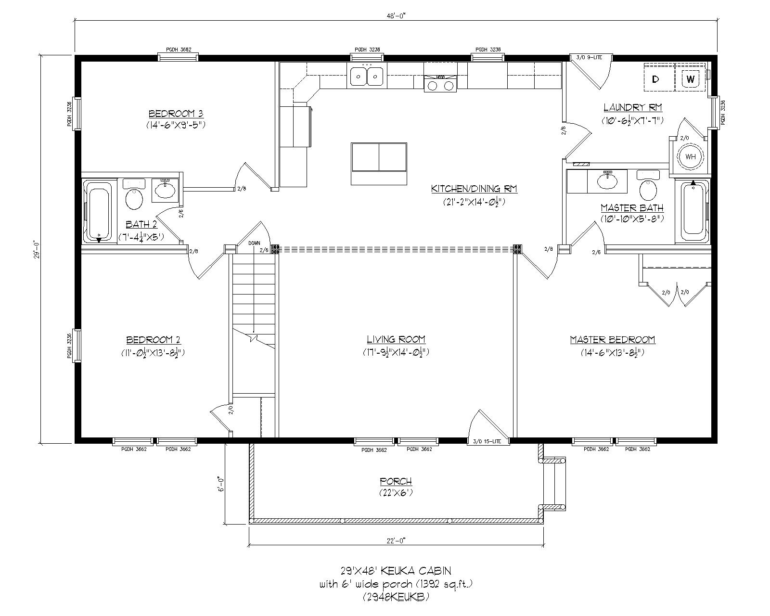](http://www.woodtex.com/cabins/keuka/floor-plans/#floorplan-6)

Storage

Public Rest Room

Member Restroom

Tool Room

Meeting Room

Office

Display Room