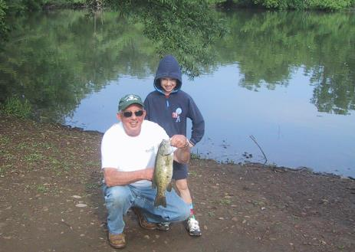
ADULT FISHING PROGRAM

SPONSORED BY: ANGLERS ASSOCIATION OF ONONDAGA
WHERE: 2004 VALLEY DRIVE (Webster Pond)
WHEN: FIRST SUNDAY IN APRIL
ENDING: LAST SUNDAY IN SEPTEMBER
HOURS:8AM TO 12NOON

COST: $15.00 PER PERSON FOR THE SEASON

AGES: 16 AND UP ARE ELIGIBLE

MEMBERS MAY NOW FISH ON SUNDAYS WITH OR WITHOUT YOUR CHILDREN.

YOU MUST BE A PAID MEMBER AND HOLD A
VALID NY STATE FISHING LICENSE.

FOR FURTHER INFORMATION PLEASE CONTACT CHAD NORTON AT 727-2922
SENIOR MEMBERSHIP APPLICATION
Date ______________

Name_____________________________________________________________

M

Address _______________________________________________

City State Zip _\

Phone_____________________ E-MAIL_____________________

CHECK TYPE OF MEMBERSHIP
_____ Original Membership _____ Renewal
ANNUAL MEMBERSHIP FEE $15.00
ANGLERS ASSOCIATION.OF ONONDAGA
2004 VALLEY DRIVE SYRACUSE N.Y. 13207
315-469-8027 OR 315-727-2922
WWW.WEBSTERPOND.ORG

I AM WILLING TO HELP WITH THE FOLLOWING

_____PASSING OUT CORN ____FUNDRAISING

______EVENTS ___MAINTENANCE
ADDITIONAL INFORMATION
OCCUPATION:
SPECIAL SKILLS:
SPECIAL INTERESTS, HOBBIES: MEMBERS SIGNATURE
____________________

