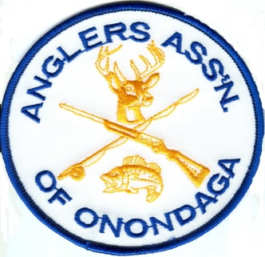

WEBSTER POND
BACK
TRAIL PROJECT

WEBSTER POND
BACK TRAIL
BRIDGES
ADA COMPLIANT PLANS

PHASE 1

Webster Pond
2004 Valley Drive
Syracuse, NY 13207
315-469-8027
www.websterpond.org

PHASE 1

3/11/14

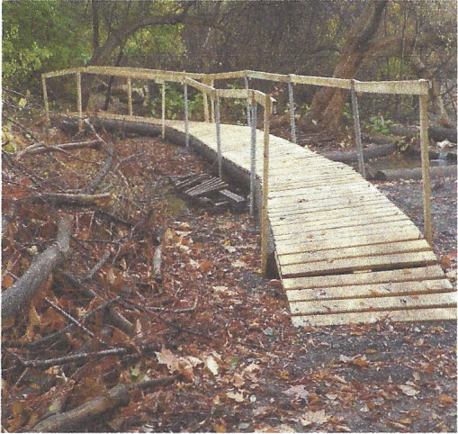
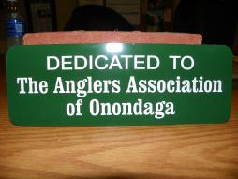
My name is Chad Norton Vice President of the Anglers Association of Onondaga that maintains
Webster Pond. This is a donation request to improve our back trail to ADA standards to improve the mobility and opportunity for the disabled. We must reconstruct the bridges as they are leaning, dilapidated, unsafe ramp incline and non ADA compliant. Fixing the bridges would make it safer for able bodied pedestrians to take guided tours for schools, summer events with the VA Hospital, Muscular Dystrophy Association and many more. The bridges are the (phase 1 proposal .At a later date we plan on making the entire trail ADA accessible if we can secure the funding. (see phase two proposal) Attached is documentation to support our reactivation, project plans, diagrams, supply list, cost estimates and photos of the trail now. Project plans and photos provided by a licensed contractor who has completed this project personally. He also agreed to help with the labor at a reduced cost. We are aware the estimate is costly, however we plan on completing it in sections as more funding becomes available Payments for labor and materials can be made to E.C.K. Tree and Outdoor. Your consideration regarding this request is greatly appreciated. We are asking for businesses to sponsor a twelve foot section at a cost of $300.00 to complete both phase 1 and two. We have 1200 feet of trail+ 100 12 foot sections. Each business donor will have a plaque installed for recognition. Should you need more information please advise.
Thank you for your time.
Sincerely, Chad Norton Vice President Angler's Association of Onondaga

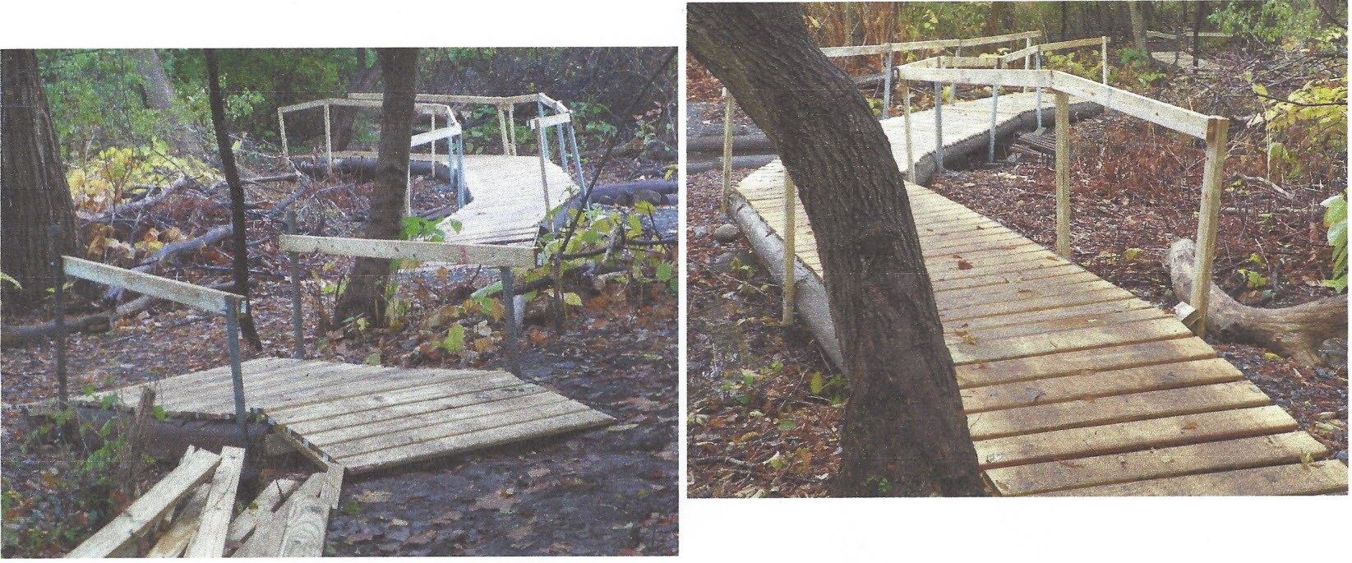
E.C.K. Tree & Outdoor
7000 So. Salina St.
Nedrow, NY 13120
315-492-3837
Quote: Handicap Accessible Trail

03/19/2014

Install 3 bridges next to existing bridges 6' wide made of poles and pressure
treated wood decking.
If the poles for bridge bases are provided by the Anglers Assn., the estimate
would be in the area of$3500.00 to $4000.00. This includes decking and the
reinforcing rods to prevent the deck from moving.
The trails from the storage shed to the Southern end of the 2013 built trail
should be edged with timber of logs and then covered with a stone base to
prevent water and mud on the trail. If the state can provide the edging it
would take approx. 125 yards of run a crush. Stone right now costs approx.
$26.00 a ton delivered. The labor to install the stone and compact it would be
$1500.00
Thanks
-.----- ;:/
~ <..~ .. ~,, __ .. _tlL.·Z _
( - ....
Tim Nelson

WEBSTER POND
BACK TRAIL
ADA COMPLIANT
PLANS
PHASE 2

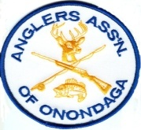
Webster Pond
2004 Valley Drive
Syracuse, NY 13207
315-469-8027
www.websterpond.org
3/11/14
PHASE2
My name is Chad Norton Vice President of the Anglers Association of Onondaga that maintains Webster Pond. This is a request for a donation to improve our back trail to ADA standards to improve the mobility and opportunity for the disabled. In addition make it safer for able bodied pedestrians to take guided tours for schools, summer events with the VA Hospital, Muscular Dystrophy Association and many more. Attached is documentation to support our reactivation, project plans, diagrams, supply list, cost estimates and photos of the trail now and of a completed project at a different location using the same plans. Project plans and photos provided by a licensed D.E.C. forester who has completed this project personally. He also agreed to help with the labor at no cost. Your consideration regarding this request is greatly appreciated. Should you need more information please advise.
Thank you for your time. Sincerely,
Chad Norton

Vice President
Angler’s Association of Onondaga

Webster Pond Accessible Trail Project

So what is an accessible trail? (from ADA website)
- Under the proposed ADA guidelines, an accessible trail would meet these minimum technical provisions:
- Clear tread width: 36" minimum. Recommend making entire trial 60" wide to avoid need for passing space required below.
- Tread Obstacles: 2" high maximum (up to 3" high where running and cross slopes are 5% or less)
- Cross Slope: 5% max.
- Running slope (trail grade) meets one or more of the following:
- 5% or less for any distance.
- up to 8.33% for 200' max. Resting intervals no more than 200' apart.
- up to10% for 30' max. Resting intervals 30'.
- up to 12.5% for 10' max. Resting intervals 10'.
- No more than 30% of the total trail length may exceed a running slope of 8.33%.
- Passing Space: provided at least every 1000' where trail width is less than 60". Not needed if trail is 60" wide or wider.
- Signs: shall be provided indicating the length of the accessible trail segment.
Design
The accessible trail will be constructed with 6 inch by 6 inch by 12 foot timbers treated for ground contact for framing. For each 12 foot long section two 6 foot long cross members will be set level and with the top at grade. Two 6 inch by 6 inch 12 foot timbers will be secured to the cross members using 10 inch Timberlok screws. The ends of each 12 foot section will be constructed by lapping the ends of each section and securing the ends together with 5 inch Timberlok screws. See attached sketch.
Each 12 foot section will be lined with filter fabric and filled with gravel that meets ADA requirements for an accessible trial surface. The gravel will be tamped to leave a minimum 2 inch (check requirement 1 or 2 inch?) height between the trail surface and the top of the 6 inch by 6 inch by 12 foot timber.

Materials
The following materials will be need per 12 foot length of trail (actually per 11.5 feet due to the over lapping of the sections):
- 6 inch by 6 inch by 12 foot timber, treated for ground contact – 3 each at $38.97 =$116.91
($38.97 at Home Depot)
- 6 inch Timberlok (or similar) screws – 8 each at $0.379 = $3.04
(250 ct is $94.86 at Home Depot)
- 10 inch Timberlok (or similar) screws – 8 each at $0.594 = $4.75
(250 ct is $148.50 at Home Depot)
- Filter fabric/geotexile, there are many types make sure to get the type that allows water to pass through – 6 feet wide by 12 feet long at .466 per foot = $5.59
(6 feet wide by 300 feet is $105.15 plus shipping, approximately $140 at Home Depot)
*Note: I used prices from Home Depot because they were easy to find online. You should be able to get a much better price, especially on the treated timbers, if you shop around.

- Gravel that meets ADA requirements for firmness and stability for accessible trial – 1.1 yards per 12 foot section.
(You will need to check with Saunder's to see what they recommend. I have had good luck with shoulderstone with 1As, but each facility has a different mix and parent material, you need something that is limestone based so that it will compact and set up hard, I believe the standard allows for a maximum stone size of 0.25 inch, but you will want to check)
Equipment
- Tamper - A tamper will be needed to compact the gravel. It will be most efficient to rent or borrow one once a large portion of the trail is ready to be compacted.
- A means of moving gravel. A small skid steer (less than 60 inches wide) is ideal, but a wheel borrow and a lot of help will work too. If you use a skid steer it will be more efficient to get a large portion of the framing completed first and then line up the skid steer and tamper at the same time.
- A heavy duty electric drill for driving the Timberlok screws.
- Various hand tools, shovels, rakes, loppers, etc.
- Chainsaw for cutting the ends of the timber for lapping.
- Saw for cutting timbers (chainsaw works great but not with people around, cut ahead of time or use a reciprocating saw.
- People/help - You will only want a few people for the first couple of work days. Once a few people know what they are doing you can call in the "reserves."
- Permits? Not sure what permits or approvals you may need from the local municipality or Webster's Pond.
Total cost per 12 feet $300.00 per twelve foot section
$116.91 twelve foot timbers
3.04 six inch timberlok screws
4.75 ten inch timberlok screws
5.59 six feet wide by twelve feet long filter fabric
$30.00 stone
Total cost for entire trail (100 twelve foot sections times $300.x100=$3000.00

